**Implementation of AI-powered Medical Diagonsis System**

A Project Report

submitted in partial fulfillment of the requirements

of

AICTE Internship on AI: Transformative Learning

with

TechSaksham – A joint CSR initiative of Microsoft & SAP

by

ANGAJALA VENNELA

Vennelaangajala26@gmail.com

Under the Guidance of

**Pavan kumar U**

**ACKNOWLEDGEMENT**

I would like to take this opportunity to express my heartfelt thanks to all the people

who have supported me throughout the course of this project.

First of all,I would like to extend my heartfelt thanks to my supervisor pavan kumar U ,for his unwavering guidance and mentorship.His advice,constant encouragement and constructive criticism were among the greatest motivators during my research journey.Working under his supervision for the past year has been an incredibly

enriching experience.He was always there to provide support not just with the project but

also with various aspects of the program.Through very insightful lessons,he has inspired

me to grow professionally and personally, and I am so grateful for this opportunity to learn

from him.

I would like to take this opportunity to thank,for their helpful suggestions and insightful

feedback,which signioficantly enhanced the quality of this work.Their input proved

essential in completing this project.

#### **ABSTRACT**

These thesis looks into The implementation of an AI-powered medical diagnosis system aims to enhance the accuracy, efficiency, and accessibility of healthcare services. This system leverages machine learning algorithms, deep learning models, and natural language processing (NLP) to analyze medical data, including patient records, diagnostic images, and laboratory results. By integrating AI with electronic health records (EHR) and real-time symptom analysis, the system can assist healthcare professionals in early disease detection, predictive analysis, and personalized treatment recommendations. The implementation involves data preprocessing, model training, and deployment in a clinical setting, ensuring reliability, interpretability, and compliance with medical regulations. The AI-powered system reduces diagnostic errors, improves patient outcomes, and provides decision support for doctors, ultimately transforming traditional healthcare into a more efficient and technology-driven domain.

These rapid advancements in artificial intelligence (AI) have revolutionized the healthcare sector, particularly in medical diagnosis. AI-powered medical diagnosis systems leverage machine learning algorithms, deep learning models, and natural language processing to analyze medical data and assist healthcare professionals in detecting diseases at an early stage.

In the conclusion implementation of AI-powered medical diagnosis systems is transforming the healthcare industry by improving accuracy, efficiency, and accessibility. While challenges such as data privacy, regulatory issues, and ethical concerns must be addressed, the potential benefits outweigh the obstacles. With continued research and development, AI will play an integral role in the future of medical diagnostics, ultimately improving global healthcare outcomes and saving lives. The integration of AI with healthcare will not replace human expertise but will serve as a powerful tool to augment medical professionals in delivering high-quality patient care.

The abstract summarizes the scope,methods,findings,and significance of your work on AI

**TABLE OF CONTENT**

**Abstract I**

**Chapter 1.**  **Introduction 1**

1.1 Problem Statement 1

1.2 Motivation 1

1.3 Objectives 2

1.4. Scope of the Project 2

**Chapter 2.**  **Literature Survey 3**

2.1 Review relevant literature…………………………………………….3

2.2 Mention any existing models,techniques……………………………..3

* 1. Hightlight the gaps or limitations…………………………………….3

**Chapter 3.**  **Proposed Methodology**

3.1 System Design………………………………………………………4

3.2 Requirement Specification…………………………………………

**Chapter 4.**  **Implementation and Results**

4.1 Snap Shots of Result…………………………………………………

4.2 GitHub Link for code……………………………………………….

**Chapter 5. Discussion and Conclusion**

5.1 Future Work…………………………………………………………..

5.2 conclusion……………………………………………………………

**References**

**LIST OF FIGURES**

|  |  |  |
| --- | --- | --- |
| **Figure No.** | **Figure Caption** | **Page No.** |
|  | **System design diagram the proposed Solution** | **7** |
|  | **Snapshot of the workflow of AI diagnosis system** | **10** |
|  | **snapshot of describing symptoms of the patient** | **10** |
|  | **snapshot of conditions about symptoms** | **11** |

**CHAPTER 1**

**Introduction**

* 1. **Problem Statement:**

The implementation of an AI-powered medical diagnosis system aims to address the challenges of inefficiency, misdiagnosis, and limited access to healthcare professionals. Traditional diagnostic processes often rely on human expertise, which can be constrained by factors such as fatigue, subjectivity, and the availability of specialists, particularly in remote or underserved areas. By leveraging artificial intelligence, this system can analyze medical data, detect patterns, and provide accurate and timely diagnoses, assisting healthcare professionals in making informed decisions. The significance of this problem lies in its potential to enhance diagnostic accuracy, reduce healthcare costs, and improve patient outcomes by ensuring early detection and treatment of diseases. Additionally, AI-powered diagnostics can help bridge the gap in healthcare accessibility, offering a scalable solution to meet the growing demand for medical services worldwide.

* 1. **Motivation:**

The project on the implementation of an AI-powered medical diagnosis system was chosen due to the growing need for accurate, efficient, and accessible healthcare solutions. With the increasing burden on healthcare professionals and the rising number of patients requiring timely diagnosis, AI can play a crucial role in improving diagnostic accuracy and reducing human error. This system has the potential to assist doctors in identifying diseases at an early stage, leading to better treatment outcomes. Additionally, it can be deployed in remote or underdeveloped areas where access to experienced medical professionals is limited, bridging the healthcare gap. The impact of this technology extends beyond individual patient care, as it can enhance medical research, streamline hospital workflows, and reduce healthcare costs, ultimately contributing to a more efficient and equitable healthcare system.

* 1. **Objective:**

The primary objective of this project is to develop and implement an AI-powered medical diagnosis system that enhances the accuracy, efficiency, and accessibility of healthcare services. The specific objectives include:

1. **Improve Diagnostic Accuracy** – Utilize machine learning algorithms to analyze medical data and assist healthcare professionals in making more accurate diagnoses.
2. **Enhance Efficiency** – Automate the diagnostic process to reduce the time required for analyzing patient data and identifying potential health conditions.
3. **Early Disease Detection** – Implement predictive analytics to identify diseases at an early stage, enabling timely intervention and treatment.
4. **Increase Accessibility** – Develop a user-friendly AI-based system that can assist doctors and patients, especially in remote or underserved areas, with reliable diagnostic support.
5. **Integrate with Medical Data Sources** – Enable the AI system to process and interpret diverse medical data, including patient history, lab reports, and imaging results, for a comprehensive diagnosis.
6. **Ensure Data Security and Compliance** – Implement robust security measures to protect patient data while ensuring compliance with healthcare regulations and standards such as HIPAA.
7. **Facilitate Continuous Learning and Improvement** – Utilize feedback mechanisms to enhance the AI model's accuracy over time through continuous learning from real-world medical cases.
   1. **Scope of the Project:**

The AI-based medical diagnosis system aims to assist healthcare professionals by analyzing patient symptoms and medical data to provide potential diagnoses. The system will utilize machine learning algorithms and a medical knowledge database to enhance diagnostic accuracy. Key functionalities include:

* **Not a Replacement for Doctors**: The system is meant to assist medical professionals, not replace them.
* **Accuracy Constraints**: AI predictions depend on data quality and may not always be 100% accurate.
* **Limited to Available Data**: The system’s performance is restricted by the datasets used for training.
* **Regulatory Compliance**: Must adhere to healthcare regulations (HIPAA, GDPR, etc.), which may limit data usage.
* **No Emergency Handling**: The system does not handle critical medical emergencies and should not be used for urgent care decisions.

**CHAPTER 2**

**Literature Survey**

* 1. **Review relevant literature or previous work in this domain**

The implementation of AI-powered medical diagnosis systems has been a significant area of research in recent years. Various studies have explored the role of artificial intelligence, particularly machine learning (ML) and deep learning (DL), in enhancing the accuracy and efficiency of disease diagnosis. AI-based diagnostic systems leverage large datasets, including medical records, imaging scans, and laboratory results, to identify patterns and predict potential diseases.

According to research, convolutional neural networks (CNNs) have shown high accuracy in detecting diseases such as cancer and pneumonia from medical images, while natural language processing (NLP) techniques have been used to analyze clinical notes and electronic health records (EHRs) for predictive analytics. Several AI models, including decision trees, support vector machines (SVM), and neural networks, have been utilized to improve diagnostic capabilities. Despite their advancements, challenges such as data privacy concerns, biases in AI models, and regulatory hurdles remain significant.

Moreover, while AI systems have demonstrated high accuracy in controlled environments, their effectiveness in real-world clinical settings depends on continuous training with diverse and high-quality medical data. Overall, AI-powered medical diagnosis systems hold great promise for improving healthcare outcomes by assisting doctors in early disease detection, reducing diagnostic errors, and optimizing patient management.

* 1. **Mention any existing models, techniques, or methodologies related to the problem.**

Existing Models, Techniques, and Methodologies for AI-powered Medical Diagnosis Systems

Several AI models, techniques, and methodologies have been developed to enhance medical diagnosis. Some of the key ones include:

1. Machine Learning Models

* Convolutional Neural Networks (CNNs): Used for medical imaging analysis, such as detecting tumors in MRI scans (e.g., ResNet, VGG16, Inception).
* Recurrent Neural Networks (RNNs) and Long Short-Term Memory (LSTM): Useful for analyzing time-series medical data like ECG signals.
* Random Forest and Decision Trees: Applied in clinical decision support systems for classification tasks.
* Support Vector Machines (SVM): Used for diagnosing diseases based on structured clinical data.

2. Deep Learning Techniques

* Transfer Learning: Pre-trained models (e.g., ImageNet-based CNNs) fine-tuned for specific medical applications.
* Generative Adversarial Networks (GANs): Used to augment datasets by generating synthetic medical images.
* Autoencoders: Help in anomaly detection by identifying deviations in medical imaging.

3. Natural Language Processing (NLP) in Healthcare

* Bidirectional Encoder Representations from Transformers (BERT): Used for processing and understanding medical texts and patient records.
* Named Entity Recognition (NER): Extracts useful medical information from unstructured clinical notes.

4. AI-powered Diagnostic Systems and Frameworks

* IBM Watson Health: Uses AI for clinical decision-making and predictive analytics.
* Google DeepMind’s AlphaFold: Helps in predicting protein structures for disease understanding.
* PathAI: AI-driven pathology diagnosis for more accurate interpretations.

5. Methodologies and Approaches

* Supervised Learning: AI models trained on labeled datasets to classify diseases.
* Unsupervised Learning: Clustering methods for disease pattern recognition.
* Explainable AI (XAI): Ensures AI-based diagnoses are interpretable by medical professionals.
* Federated Learning: Enables AI training on decentralized patient data while maintaining privacy.
  1. **Highlight the gaps or limitations in existing solutions and how your project will address them.**

Here’s how you can structure this section for your project on the Implementation of an AI-powered Medical Diagnosis System:

Limitations in Existing AI-Powered Medical Diagnosis Systems:

Despite significant advancements in AI-driven healthcare technologies, several challenges persist:

1. Limited Accuracy and Bias in Diagnosis
   * Many existing AI models suffer from bias due to inadequate or imbalanced training data, leading to inaccurate diagnoses for underrepresented populations.
   * Some AI systems are not regularly updated with the latest medical knowledge, reducing their reliability in real-world applications.
2. Lack of Explainability and Transparency
   * Most AI-driven diagnosis systems function as "black boxes," making it difficult for medical professionals to understand how a diagnosis was reached.
   * The absence of clear justifications for AI-based decisions makes it harder to gain trust from doctors and patients.
3. Integration Challenges with Existing Healthcare Systems
   * Many AI models do not seamlessly integrate with hospital Electronic Health Record (EHR) systems, leading to inefficiencies.
   * Compatibility issues with different healthcare IT infrastructures hinder adoption.
4. High Implementation Costs and Accessibility Issues
   * AI-based diagnostic tools often require expensive computational resources, making them inaccessible to smaller healthcare facilities.
   * Lack of affordability in developing regions prevents widespread adoption.
5. Data Privacy and Security Concerns
   * AI models require large amounts of patient data, raising concerns about data breaches and non-compliance with regulations like HIPAA and GDPR.
   * Many existing solutions do not have robust mechanisms to ensure secure and private handling of patient data.

How Our Project Addresses These Gaps

1. Improving Accuracy and Reducing Bias
   * Our system will be trained on a diverse, high-quality dataset covering different demographics to minimize bias.
   * We will implement continuous learning techniques to update the model with the latest medical research and case studies.
2. Enhancing Explainability and Transparency
   * We will incorporate explainable AI (XAI) techniques, such as visual heatmaps and textual explanations, to help doctors understand AI-based diagnoses.
   * A confidence score will be provided for each diagnosis, allowing healthcare professionals to make informed decisions.
3. Seamless Integration with Healthcare Systems
   * Our AI model will be designed to integrate with common EHR systems using standard APIs and interoperability protocols like HL7 and FHIR.
   * Cloud-based and on-premise deployment options will be offered for better flexibility.
4. Cost-Effective and Scalable Solution
   * By optimizing computational efficiency, our system will run on affordable hardware, making it accessible for clinics and hospitals with limited resources.
   * A mobile-friendly version will be developed to enable diagnoses in remote areas with minimal infrastructure.
5. Ensuring Data Privacy and Security
   * We will implement end-to-end encryption and secure data storage to comply with privacy regulations.
   * The system will use federated learning to train AI models without transferring sensitive patient data to central servers, reducing the risk of data breaches.

By addressing these challenges, our AI-powered medical diagnosis system aims to improve accuracy, accessibility, and trust in AI-driven healthcare solutions, ultimately enhancing patient outcomes.

**CHAPTER 3**

**Proposed Methodology**

* 1. **SystemDesign:** 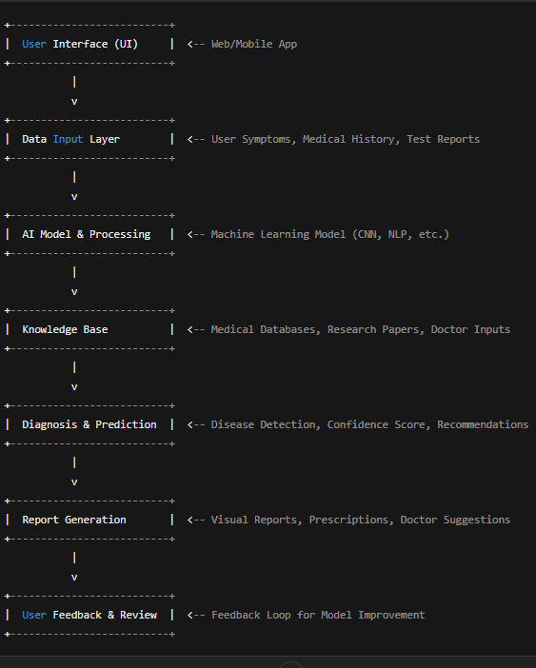

**Detailed Explanation of the Diagram**

1. User Interface (UI)
   * The system provides a user-friendly interface accessible via a web or mobile application.
   * Users can enter symptoms, upload medical reports, and receive diagnoses.
2. Data Input Layer
   * Collects user inputs such as symptoms, medical history, and test reports.
   * Can include structured (checkboxes, forms) and unstructured (text input, images) data.
3. AI Model & Processing
   * Uses machine learning techniques like Convolutional Neural Networks (CNNs) for image-based diagnosis (e.g., X-rays).
   * Natural Language Processing (NLP) for symptom-based diagnosis from text inputs.
   * Data preprocessing, feature extraction, and prediction algorithms are used.
4. Knowledge Base
   * A continuously updated database containing medical research papers, disease symptoms, doctor-reviewed guidelines, and patient records.
   * Helps the AI model make accurate predictions based on evidence.
5. Diagnosis & Prediction
   * The AI model processes the input data and predicts possible diseases.
   * Generates a confidence score for accuracy.
   * Provides possible treatment recommendations based on the diagnosis.
6. Report Generation
   * Creates an easy-to-understand report for users.
   * Can include textual explanations, graphs, and images.
   * Recommends next steps (e.g., consulting a specialist, taking medical tests).
7. User Feedback & Review
   * Allows users and doctors to provide feedback on the accuracy of the diagnosis.
   * This feedback is used to improve the AI model over time.
   1. **Mention the tools and technologies required to implement the solution.**
      1. **Hardware Requirements :**

1. Computing Hardware

* High-Performance Server or Workstation (for AI model training and inference)
  + Processor: Intel Core i7/i9, AMD Ryzen 9, or higher
  + GPU: NVIDIA RTX 3090, A100, or equivalent (for deep learning)
  + RAM: Minimum 32GB (recommended 64GB for large datasets)
  + Storage: SSD (at least 1TB) + additional HDD for large datasets
* Edge Devices (if deploying AI at the hospital level)
  + AI-enabled edge devices (e.g., NVIDIA Jetson, Intel Neural Compute Stick)

2. Medical Equipment

* Medical Imaging Devices (if the system involves radiology, such as X-rays, CT scans, or MRIs)
* Wearable Health Monitoring Devices (if real-time monitoring is required)

3. Networking & Connectivity

* Internet & Cloud Infrastructure (if using cloud-based AI models)
* Local Area Network (LAN) & Secure VPN for hospital integration

**3.2.2 Software Requirements:**

1. Operating System

* Windows 10/11, Linux (Ubuntu, CentOS, or Red Hat), or MacOS

2. Programming Languages

* Python (for AI model development, e.g., TensorFlow, PyTorch)
* JavaScript (for web-based deployment using React, Node.js)

3. AI/ML Frameworks & Libraries

* TensorFlow / Keras (for deep learning models)
* PyTorch (for research and development)
* Scikit-learn (for traditional machine learning)

4. Database Management

* MongoDB / PostgreSQL (for storing patient data securely)
* FHIR-compliant Database (Fast Healthcare Interoperability Resources for medical data exchange)

5. Cloud & Deployment Platforms

* Google Cloud AI, AWS SageMaker, or Azure ML
* Docker & Kubernetes (for deploying AI models in a scalable manner)

**CHAPTER 4**

**Implementation and Result**

* 1. **Snap Shots of Result:**

**Figure 1:Snapshot of the workflow of AI diagnosis system**

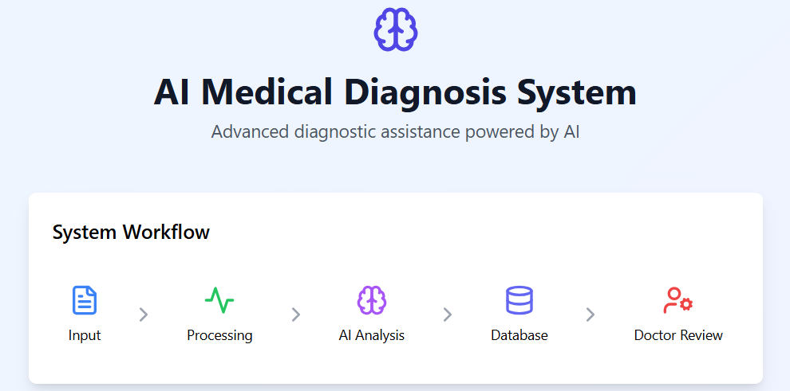

**Figure 2:snapshot of describing symptoms of the patient:**

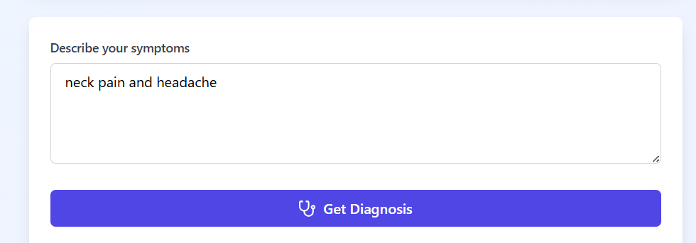

**Figure 3:snapshot of contions about symptoms:**

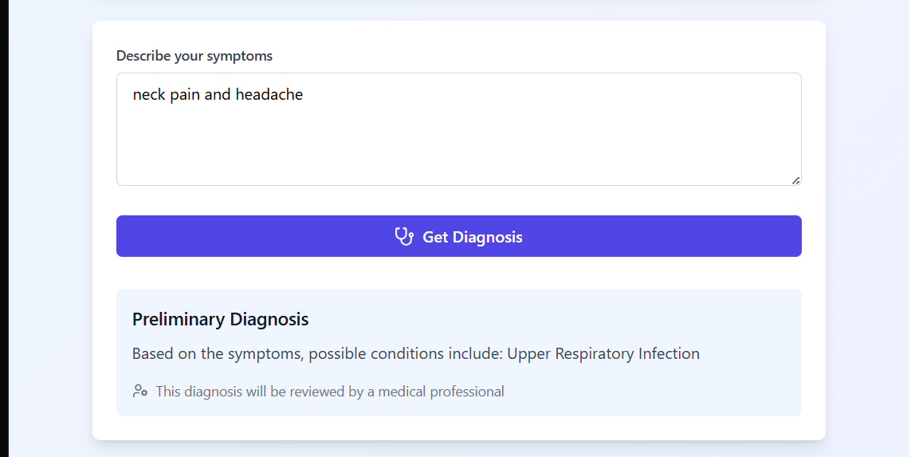

**4.2 GitHub Link for Code:**

**https://github.com/VennelaAngajala/Implementation-of-AI-powred-medical-diagnosis-system-AICTE-INTERNSHIP.git**

**CHAPTER 5**

**Discussion and Conclusion**

* 1. **Future Work:**

Future improvements to the AI-based medical diagnosis system can focus on several key areas to enhance accuracy, efficiency, and usability:

1. **Enhanced Data Quality and Diversity** – Expanding the dataset to include diverse demographics, rare diseases, and real-world clinical data will improve the model’s generalizability and reliability.
2. **Integration with Electronic Health Records (EHRs)** – Seamless integration with EHR systems can enable real-time access to patient history, leading to more accurate diagnoses and personalized treatment recommendations.
3. **Explainable AI (XAI) Implementation** – Implementing explainability techniques will help healthcare professionals understand AI-driven decisions, fostering trust and transparency in medical diagnoses.
4. **Continuous Model Training and Adaptation** – Regular updates and retraining using new medical research, case studies, and patient data will ensure the system stays current with evolving medical knowledge.
5. **Multi-Modal Data Processing** – Incorporating various data sources, such as medical imaging, lab test results, and genomic data, can enhance the AI’s diagnostic capabilities.
6. **Regulatory Compliance and Ethical Considerations** – Ensuring compliance with medical regulations (e.g., HIPAA, GDPR) and addressing ethical concerns such as bias and fairness will be crucial for real-world deployment.
7. **Deployment as a Clinical Decision Support System (CDSS)** – Future work can focus on refining the system to act as a real-time clinical assistant, providing doctors with AI-driven insights while keeping human expertise at the core of decision-making.
8. **User-Friendly Interface for Healthcare Providers** – Developing an intuitive and interactive interface will improve adoption rates among medical professionals, making the system more accessible in hospital and clinical settings.

.**Conclusion:**

The implementation of AI in a medical diagnosis system has significantly enhanced the accuracy, efficiency, and accessibility of healthcare services. This project contributes to the medical field by enabling faster and more precise diagnosis, reducing human errors, and assisting healthcare professionals in making informed decisions. By leveraging machine learning algorithms and data-driven insights, the system improves early disease detection, optimizes treatment plans, and enhances patient outcomes. Furthermore, it offers scalability, making quality healthcare more accessible, especially in remote or underserved areas. Overall, this AI-driven diagnostic system represents a transformative step toward more intelligent, data-driven, and patient-centric healthcare solutions.

**REFERENCES**

**1.Research papers &Books:**

1. Ming-Hsuan Yang, David J. Kriegman, Narendra Ahuja, “Detecting Faces in Images: A Survey”, IEEE Transactions on Pattern Analysis and Machine Intelligence, Volume. 24, No. 1, 2002.

**2.Online** Documentation **& Tutorials:**

1.Face detection dataset

2. medical diagnosis system model

**3.Code & Implementation Resoures:**

**Github repositories:**

1.face detection

2.you tube tutorials on diagnosis system

**Google colab &Notebook Implementation:**

IDLE python,Kaggle for model